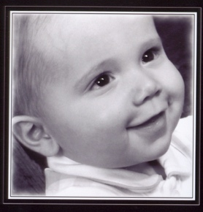
Benton’s Family Assistance Fund
Grant Request Form

Ian and Marie Auerbach established Benton's Family Assistance Fund within NTSAD to honor their son, Benton, who passed away from Tay-Sachs in January 2012, at the age of 3. They started this fund to provide financial assistance to families and affected individuals to purchase items and services that promote comfort, ease, and quality of life for their loved ones. Like Helping Hand Grants, grants from Benton's Family Assistance Fund will aid families and individuals that are otherwise unable to afford these very helpful services.

Eligibility
- NTSAD Peer Support Group members
- Family member taking care of a child
- Affected adults & their caregivers

Examples of what's covered in the Fund:
- strollers
- equipment that helps increase comfort (e.g,. positioning equipment for children) but isn't covered by medical insurance
- durable medical equipment co-pay
- short-term respite or nursing care
- complimentary medicine, e.g., occupational therapy, Eastern medicine approaches

Guideline for amount requested:
The maximum request should be $500 per year for each family. However, the amount ultimately granted, and the item approved will be at the discretion of the grant review committee. For equipment requests, or shipment of equipment, it is required that these items are well-cared for, and, when the time comes, the equipment is forwarded to another family in need.

NOTE: International shipment from the United States is more expensive due to customs fees and can be a lengthy process.

How to apply:

To apply for a grant, please submit fill out the form and email to Becky Benson, Family Services Manager, at becky@ntsad.org. Once you are awarded the grant, you will be asked to submit documentation for the item/service per NTSAD's audit requirements.

Benton’s Family Assistance Fund
Grant Request Form

Name (First and last):
Address, City, State, Zip:
Name of your affected child(ren):
Age(s):

Request description:

Cost of item requested:

Briefly describe why you’re requesting help:

Are you able to contribute toward the cost? If so, how much?

What amount do you need help with?

Please submit this form along with a photo of your child(ren) who are affected by Canavan, GM1, Sandhoff or Tay-Sachs by email to Becky Benson, Family Services Manager, becky@ntsad.org.

